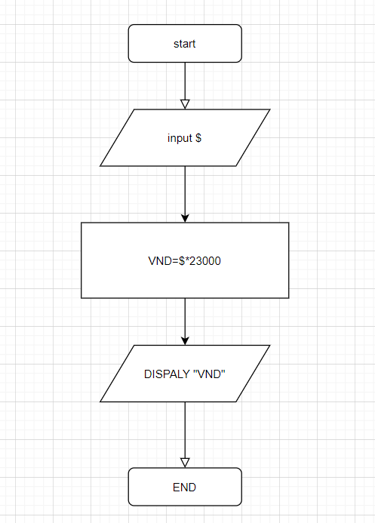

BEGIN

INPUT $;

VND=$\*23000;

DISPLAY “VND”;

END